**INTERNET OF THINGS MINOR PROJECT**

**PASSWORD DOORLOCK SYSTEM USING ARDUINO UNO**

Name : Jaidhev Anandhev

Batch : April 5th batch

Duration : 2 months

Project Abstract :

This project is about creating a password enabled door lock system using Arduino board and Arduino software .

Table of contents :

1. Introduction of Arduino
2. Why Arduino is used in most of the smart devices.
3. Application of Arduino
4. Steps to create password door lock system.
5. Simulation of automated door lock system.

**INTRODUCTION OF ARDUINO:**

Arduino is a microcontroller platform that allows you to create interactive projects using electronics, programming, and creativity. It is an open-source platform, which means that the hardware and software are freely available to everyone. This makes it a great option for beginners and experienced users alike. Arduino boards are made up of a microcontroller, which is a small computer that can be programmed to perform specific tasks. The microcontroller is connected to a variety of input and output ports, which allow you to interact with the physical world. For example, you can use input ports to read data from sensors, such as light sensors or buttons. You can use output ports to control devices, such as motors or LEDs. Arduino is programmed using a simple programming language called C++. C++ is a powerful language that allows you to create complex projects. However, Arduino also includes a simplified version of C++ called Arduino Sketches, which is designed for beginners.

**WHY ARDUINO IS USED IN MOST OF THE SMART DEVICES:**

**OPEN-SOURCE:** Arduino is an open-source platform, which means that the hardware and software designs are freely available for anyone to use, modify, and improve. This makes it a great platform for people who want to learn about electronics and programming, or who want to create custom devices that meet their specific needs.

**EASY TO USE:** Arduino boards are designed to be easy to use, even for people with no prior experience with electronics or programming. The Arduino IDE (Integrated Development Environment) provides a graphical user interface that makes it easy to write code and upload it to the Arduino board.

**INEXPENSIVE:** Arduino boards are relatively inexpensive, making them a cost-effective option for many projects. The basic Arduino Uno board costs around 650 Rs and there are many other options available for different projects and budgets.

**APPLICATION OF ARDUINO**

Arduino is a great platform for creating a wide variety of projects. Some popular projects include:

**ROBOTICS:** Arduino can be used to create robots that can move, sense, and interact with the world.

**HOME AUTOMATION:** Arduino can be used to control devices in your home, such as lights, thermostats, and security systems.

**WEARABLES:** Arduino can be used to create wearable devices, such as fitness trackers and smart watches.

**IoT:** Arduino can be used to connect devices to the internet, allowing them to collect and share data.

**STEPS TO CREATE PASSWORD DOOR LOCK SYSTEM USING ARDUINO:**

This project has been simulated using Tinker CAD. The steps to be followed on designing password door lock system are as follows :

STEP 1 :

Open Tinker CAD website using the link below.

<https://www.tinkercad.com/dashboard>

STEP 2 :

Select Arduino UNO R3 board.

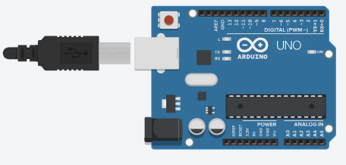

STEP 3:

Select Keypad 4X4.

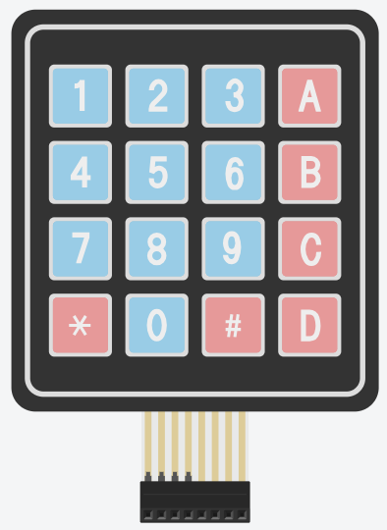

STEP 4 :

* Select Row 1, Row 2, Row 3, and Row 4 to D0, D1, D2, D3 in Arduino board. D0, D1, D2, D3 are the digital inputs of Arduino board.
* Select Column 1, Column 2, Column 3, and Column 4 to D4, D5, D6, D7 in Arduino board. D4, D5, D6, D7 are the digital inputs of Arduino board.

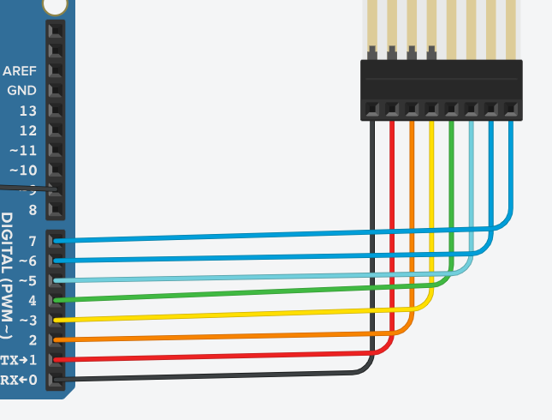

STEP 5 :

Select LCD 16 X 2 Display

This is the LED Cathode Display used.

STEP 6 :

In LCD Display connect the following ports below:

* Ground (LCD ) to Ground (GND -> Power row in Arduino)
* VCC to 5V
* Connect contrast along with resistor to the ground(GND) of LCD.
* Register select (RS) to GND of LCD.
* Enable to AnalogInput (A1) of Arduino.
* DB4 to AnalogInput (A2) of Arduino.
* DB5 to AnalogInput (A3) of Arduino.
* DB6 to AnalogInput (A4) of Arduino.
* DB7 to AnalogInput (A5) of Arduino.
* LED port of LCD through resistor to 5V of Arduino board (Power Row).
* LED port of LCD to ground.

STEP 7:

Select Micro Servo object in Tinker CAD.

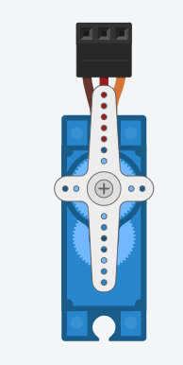

STEP 8 :

* Select GND of Micro Servo to the GND of Arduino board.
* Select Power of micro servo to 5V in Arduino Power supply.
* Select signal to the Digital input (D9) of Arduino board.

**STEP 9 :**

Paste the following code to the Text option in Tinker CAD.

#include <Keypad.h>

#include <LiquidCrystal.h>

#include <Servo.h>

#define Password_Length 5

Servo myservo;

LiquidCrystal lcd(A0, A1, A2, A3, A4, A5);

int pos = 0;

char Data[Password_Length];

char Master[Password_Length] = "1234";

byte data_count = 0, master_count = 0;

bool Pass_is_good;

bool door = false;

char customKey;

/*---preparing keypad---*/

const byte ROWS = 4;

const byte COLS = 4;

char keys[ROWS][COLS] = {

{'1', '2', '3', 'A'},

{'4', '5', '6', 'B'},

{'7', '8', '9', 'C'},

{'*', '0', '#', 'D'}

};

byte rowPins[ROWS] = {0, 1, 2, 3};

byte colPins[COLS] = {4, 5, 6, 7};

Keypad customKeypad( makeKeymap(keys), rowPins, colPins, ROWS, COLS);

/*--- Main Action ---*/

void setup()

{

myservo.attach(9, 2000, 2400);

ServoClose();

lcd.begin(16, 2);

lcd.print("Protected Door");

loading("Loading");

lcd.clear();

}

void loop()

{

if (door == true)

{

customKey = customKeypad.getKey();

if (customKey == '#')

{

lcd.clear();

ServoClose();

lcd.print("Door is closed");

delay(3000);

door = false;

}

}

else

Open();

}

void loading (char msg[]) {

lcd.setCursor(0, 1);

lcd.print(msg);

for (int i = 0; i < 9; i++) {

delay(1000);

lcd.print(".");

}

}

void clearData()

{

while (data_count != 0)

{

Data[data_count--] = 0;

}

return;

}

void ServoClose()

{

for (pos = 90; pos >= 0; pos -= 10) {

myservo.write(pos);

}

}

void ServoOpen()

{

for (pos = 0; pos <= 90; pos += 10) {

myservo.write(pos);

}

}

void Open()

{

lcd.setCursor(0, 0);

lcd.print("Enter Password");

customKey = customKeypad.getKey();

if (customKey)

{

Data[data_count] = customKey;

lcd.setCursor(data_count, 1);

lcd.print(Data[data_count]);

data_count++;

}

if (data_count == Password_Length - 1)

{

if (!strcmp(Data, Master))

{

lcd.clear();

ServoOpen();

lcd.print(" Door is Open ");

door = true;

delay(5000);

loading("Waiting");

lcd.clear();

lcd.print(" Time is up! ");

delay(1000);

ServoClose();

door = false;

}

else

{

lcd.clear();

lcd.print(" Wrong Password ");

door = false;

}

delay(1000);

lcd.clear();

clearData();

}

}

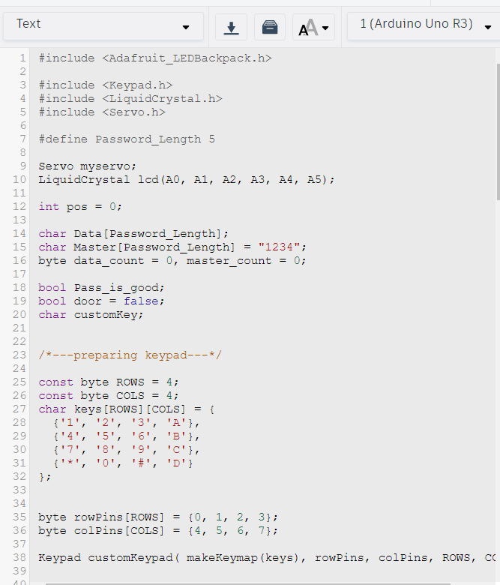

STEP 10 :

After pasting this code then select Run Simulation.

**SIMULATION OF AUTOMATED DOOR LOCK SYSTEM:**

See how the simulation works by opening the video attached along with the attachment in Google Classroom.